REPUBLICAN WOMEN OF DANE COUNTY

SEPTEMBER 2016 President: Nancy Bartlett
845-6609
email:bartnj@tds.net
website :http://rwdcweb.weebly.com

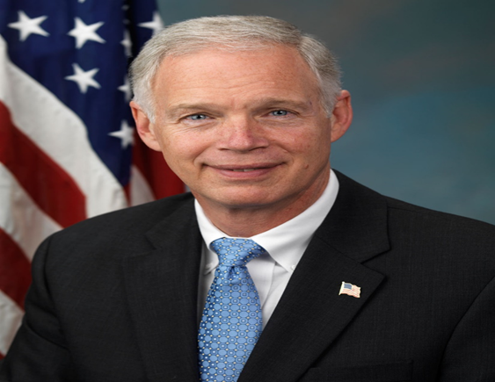

DON’T MISS OUR MEET & GREET RALLY FOR U.S. SENATOR RON JOHNSON
ON SATURDAY, OCTOBER 1 AT THE VICTORY CENTER

The RWDC is pleased that Sen. Ron Johnson has accepted our invitation to host a campaign event for him that is free and open to all Republican supporters. You will have the opportunity to meet him in person. Sen. Johnson will be discussing current issues. It is scheduled from 6 p.m. until 8 p.m. Our club will provide snacks and drinks. Our RWDC members are providing the food so you are welcome to bring finger desserts such as cookies or brownies, fruit, or vegetables on serving plates. Other food and the drinks will be purchased by our Club. The event will be indoors in case we have inclement weather. You are encouraged to spread this information so invite others (it is NOT limited to women) to come along. Please park in the rear of the office building. Pick up yard signs, etc. Bring your checkbooks if you wish to make a campaign contribution. Go green for Ron! Let’s show him he has many supporters in Dane County! The event flyer is included with this newsletter.

URGENT: CLUB VOLUNTEERS NEEDED ON SEPT. 26 AT THE EXECUTIVE RESIDENCE

The staff at the Executive Residence have contacted our Club to request volunteers for their golf outing next Monday, September 26, to be held at the Maple Bluff Country Club. It starts at 8:30 a.m. and runs until 5 p.m. so we need many ladies in shifts to help with this event. As you may know, our club is the only club in the state that has this privilege and you can count your volunteer hours. Contact Carol Grabins for more info and to volunteer – 798-3778 or grabins@tds.net.
DEBATE PARTY
Then, the same evening, you are invited to a party sponsored by RPDC at the Victory Center to watch the first televised presidential debate. The debate begins at 8 o’clock and the party begins at 7 p.m. Watch and cheer for Trump with other supporters. There is no charge to attend.

Presidents Corner
Women for Trump, Women for Ron Johnson, Women for ALL candidates. We know that women have the power and knowledge to help any and all campaigns. The recent polls show that Donald Trump and Ron Johnson are within 3 points of winning Wisconsin. With a little extra help, we can turn those polls into the positive column. Wisconsin hasn’t elected a Republican president since Ronald Reagan. I am so excited that 2016 may be the year we do can that again! Wisconsin is a purple state, let’s make it red! At our luncheon Oct. 21st, wear red to the luncheon, even a red hat if you have one. Let’s let everyone know our commitment to make Wisconsin red.
Catch the excitement,
Nancy

NEXT LUNCHEON
FRIDAY, OCTOBER 21
Blackhawk Country Club
Social Time: 11:30 a.m.
Luncheon: Noon

SPEAKERS WILL BE CANDIDATES ON THE NOVEMBER 8 BALLOT
ELECTION OF WRDC OFFICERS

This program will be a candidate forum with the Republican candidates who will be on our November ballot including for President, U.S. Senate, U.S. 2nd District Representative, and the Wis. Senate and Assembly. Peter Theron, running against Mark Pocan, will be there and it is likely we will have speakers representing Ron Johnson and Donald Trump. It is early yet to have many of the names confirmed at this time.

We will also feature our election of club officers for the next two year term of office for our RWDC Club. Information regarding the proposed slate is listed below.

October Luncheon Reservation Form

Reservation deadline: Wednesday, Oct. 19

Please reserve ______ places at $16 each for the Friday, October 21 luncheon at the Blackhawk Country Club.

Name__________________________________________ Phone ________________
Make your check payable to RWDC. Call or email your reservation to:
Sharanne Stitgen
3609 Mammoth Trail
Madison, WI 53719
Phone – 848-8835
Email: sstitgen@tds.net if you will pay at the door.
*Note: it is our policy that if you make a reservation and then not attend, you will be responsible for payment since we ordered a meal for you.

RWDC OFFICER ELECTIONS

Our club will be holding our biennial election of new officers at the October meeting for the next 2 year term starting in January 2017. The proposed slate of officers from the nominating committee is as follows:

President – Nancy Bartlett
1st Vice President – Bonnie Hall
2nd Vice President – Joyce Waldrop
Treasurer – Bev Maddrell
Recording Secretary – Angie Bausch
Corresponding Secretary – Lee Gasper Galvin
Advisors – Marilyn Stauter, Bev Maddrell and Sharanne Stitgen
Nominating Committee for 2019 term – determined day of election

Thanks to the 5-member nominating Committee members: Marilyn Stauter (Chair), Lee Gasper-Galvin, Bev Maddrell, Carol Grabins, and Ruth G. Johnson. All current RWDC members are eligible to vote at the election meeting.

JOIN WIS. WOMEN FOR TRUMP

Morgan Duffey, wife of Mike Duffey who is the Executive Director of the Republican Party of Wisconsin, is leading up the Wisconsin Women for Trump effort and will keep up informed of local activities so we will be notifying you by email frequently, often with short notice. The first thing you can do is to join us. Their new website has been launched and ready to recruit new members. The link is http://www.wwft2016.com. Feel free to share the link with family and friends. Let’s make this campaign effective – the election is less than 50 days awayl

The Trump campaign is being run out of the many Victory Centers across the state and as you may know, we have one established in Fitchburg at 2976 Triverton Pike Drive located off of county highway PD (McKee Road). Jordan Wileman is currently the field director and you may remember meeting him at our May luncheon. He is dedicating his efforts toward re-electing U.S. Senator Ron Johnson, electing a Republican President and electing Republicans up and down the ballot. This is going to be an important election and help is needed to defeat Hillary and to declare victory on November 8th! Please contact him if you are interested in getting involved. His phone number is 358-4545 and his e-mail is jwileman@wisgop.org. Every Wednesday evening will be Ladies Night at the Victory Office. From 6-8 come and make phone calls or help with other projects. From 8-8:30 is social time, talk with other women, and even have a glass of wine if you want to bring it.

RWDC HONORED CONSTITUTION DAY

Several members of our Club participated in an event for Constitution Day, nationally designated on Sept. 16th, to commemorate the signing of America’s foundational document. The event was held on Saturday, Sept. 17th at the Madison Victory Center. There was a group reading of the Preamble. The event was in coordination with the National Federation of Republican Women, the Wis. Women for Trump coalition, and there were similar programs in several other Wis. Counties.
WANT TO VOTE EARLY? NOW YOU CAN!

For the first time, Madison residents can vote early, by absentee ballot, at 12 sites other than the clerk’s office. Early voting will begin Monday, September 26th for the November election. There will also be expanded hours, including weekend hours at some public libraries. There are nine public libraries: the Central Library, the Alicia Ashman Library, Goodman South Madison Library, Hawthorne Library, Meadowridge Library, Monroe Street Library, the Lakeview Library, the Pinney Library, and the Sequoya Library; additionally, voters can cast their absentee ballots at Edgewood College, UW-Madison Union South, and the City’s East Side Streets Division. The hours vary at the different sites. *Please note that this is NOT what Republican lawmakers enacted in election reform legislation to limit early and absentee voting in an effort to make such voting uniform throughout the state, but Federal Judge James Peterson on July 29 ruled against the law - thus enabling municipal clerks to expand different times than the GOP law allowed. Remember to bring your voter ID.

RWDC LIBRARY PROJECT

Past President Marilyn Stauter and current President Nancy Bartlett spoke at the quarterly meeting of the Dane County Library Board Sept 1st. The head of the Board and most of the librarians from each of the Dane
County libraries were in attendance. We talked about our project to donate one copy of Bill O'Reilly's book Killing the Rising Sun to each of the libraries. It was an opportunity to share information about RWDC as well. We were very well received.
The books were ordered through the Dane County library system. We will sign the books and return them to the system for distribution. Then we will be doing a book presentation to the Verona Library and have more pictures to send to the media. This is an excellent community outreach project and a way for more
information to get out about Republican Women of Dane County.

THE RWDC MEMBER DIRECTORY

There are two changes to the current RWDC Directory:

Barbara Main has moved – her new information is as follows: her new address at All Saints is 511 Commerce Dr #316, Madison, WI 53719. Phone 827-3628.

Please correct the telephone number for Mary Baldwin – it should be 841-1481.

NEW RWDC MEMBERS

We welcome the following ladies to our Club:

Angie Bausch Barbara Bruni
10902 Stockbridge Rd #202 2925 Marina Dr
Madison, WI 53718 Middleton, WI 53562
563-422-1191 does not want listed
Email – angelambausch@gmail.com Email – bbcsl@tds.net

Judy Tollefson (Russell)
6405 Irving Dr
Sun Prairie, WI 53590
576-0610
Email – jtjtjt41@charter.net

Please add the information for these new members in your directory.

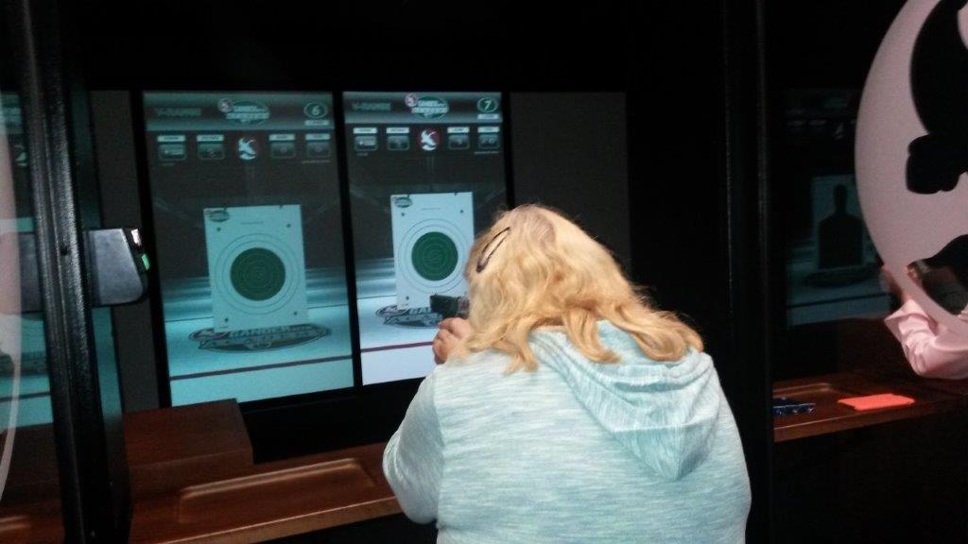

RWDC 1st Vice President Bonnie Hall shown aiming at the target

LADIES AT THE RANGE EVENT

Our first Ladies at the Range event last month was a big hit - we had a blast! (sorry about the pun).
We had 9 people attending and used everything that Gander Mountain had to offer - the live indoor range, the virtual target range, and the virtual rooms. Some brought their own guns and everyone tried their
hand on the virtual ranges with air guns. We discovered that some of us are great shots and that some of us are learning. Thursdays are ladies night at half price so the cost to each of us was minimal. We enjoyed a great dinner at the Pine Cone Restaurant after the event. Everyone agreed that we need to do this again. Watch for more information about our next Ladies at the Range night. Everyone is welcome, no experience necessary. That special man in your life is welcome too.

We send both sympathy wishes and get well wishes to RWDC member and officer Muriel Coleman. Muriel’s brother Robert (Bob) passed away and then just weeks later she underwent triple bypass open heart surgery in August followed by rehab at Oakwood West. She is now at home recuperating and doing physical therapy.

Other dates for your interest:
Oct. 4 – Vice Presidential Debate – 8 p.m.
Oct. 9 – 2nd Presidential Debate – 8 p.m.
Oct. 19 – 3rd Presidential Debate – 8 p.m.
NOVEMBER 8 – ELECTION DAY

Authorized and paid for by RPDC, Beverly Maddrell, Treasurer

